Kildare Age Friendly County Programme
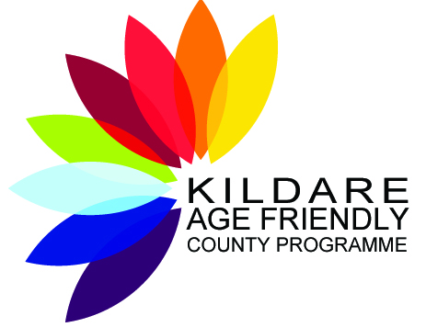
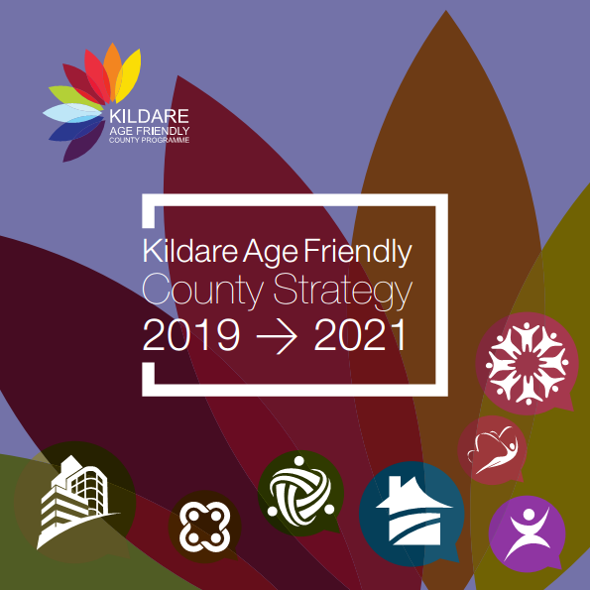
TABLE OF CONTENTS
PROGRESS REPORT
2020
FOREWORDS_____________________________________________________________ 3
From John Malone____________________________________________________ 3
From Monica Cox_____________________________________________________ 4
INTRODUCTION___________________________________________________________ 6
PROGRESS REPORTS_____________________________________________________ 8
Housing_____________________________________________________________ 8
Library Services______________________________________________________ 10
Art Services_________________________________________________________ 10
Transportation_______________________________________________________ 11
Social Participation___________________________________________________ 11
Respect & Social Inclusion_____________________________________________ 11
Town & Village Renewal/Walkability Audits________________________________ 11
Communication & Information___________________________________________12
All Thematic Areas____________________________________________________13

Foreword – Kildare Age Friendly Alliance
The year 2020 has certainly been a most challenging year for everyone, none more so than for the elderly. From people living in a family or a care home setting, the level of isolation experienced by them has been unprecedented. This ultra-resilient cohort of society have been forced to deal with loneliness, extremely serious illness and on occasion even death, if not their own, then that of a loved one. The ongoing fear factor in their lives is very wearing and will remain with them for some time to come.
From an Age Friendly perspective, sterling efforts have been put into effect by all our service providers who sit on the Alliance. Their efforts have been second to none in order to meet both the immediate and ongoing needs of the older people in Kildare. This is clearly shown in this report. A much more enhanced effort was made to partner up with other organisations and deliver on specific projects in conjunction with their own services. A practical example was the delivery of 150 Christmas hampers and 1000 resource packs to the homes of older people in December. Our Alliance were fortunate in that they got to complete their commitment of two meetings a year in 2020 and the Kildare Older Persons Executive held their bi-monthly meetings via Zoom.
This annual report covers the middle year of the Kildare Age Friendly County Strategy 2019-2021 and efforts will be made in 2021 to review this Strategy and make preparations for what will be the 4th Kildare Age Friendly County Strategy. Many lessons have been learned and new methods of service provision has been born in the past year, some of which will be replicated in the future. We are continuously looking at new and more effective ways of delivering our services and we are anxious to adopt best practice and new ideas wherever we can find them. I wish to extend my sincerest gratitude for all the efforts made, above and beyond the call of duty, by the members of the Alliance in 2020 and I believe that every effort was made to reach and serve the elderly in Kildare, whether in a rural or urban setting and the most vulnerable.

John Malone – Chairperson Kildare Age Friendly Alliance

Kildare Older Persons Council
Despite the many obstacles created by Covid-19, Kildare Older Person’s Council Executive managed to continue its work in 2020. We adapted our methods, learned new digital skills and moved much of our activity to teleconferencing platforms such as Zoom and Microsoft Teams. We held a total of four Executive Meetings in 2020, three of which were online. Many of our members worked very hard to help and support older and vulnerable people during the pandemic through their ongoing involvement in various community groups and local initiatives. This was done quietly, diligently, without fanfare and this needs to be acknowledged.

The Chairperson of Kildare OPC Executive represented the views of older people at meetings of the Kildare Age Friendly Alliance, County Kildare Joint Policing Committee (JPC), its Municipal District sub-groups and also joined the JPC’s CCTV Sub-Committee during the year.

Our Chairperson also participated in meetings of the National Network of Older Person’s Councils. An enormous amount of work was undertaken at national level through Age Friendly Ireland in 2020 by means of online meetings and consultations. In particular, a number of highly important reports were progressed, and we are advised, are close to publication, such as:

Age Friendly Primary Care Centre Guidelines
Age Friendly Airport Guidelines
Rightsizing Research Report (Housing)
Age Friendly Business Toolkit

In relation to the Age Friendly Primary Care Centre Guidelines, some members of Kildare Older Person's Council Executive previously participated in two consultation workshops with the HSE about the design, function, and layout of Primary Care Centres. We are very pleased that our involvement has projected the voices of older people directly into this significant document.

Kildare OPC Executive, through its Chairperson, also engaged with quite a few online research projects, surveys, webinars and focus groups across 2020, representative examples being:

The World Health Organisation’s Survey: Improving the Covid-19 Response for Older People
An Garda Siochana’s Survey: Lessons, Learnings & Future Opportunities for Kildare
Championing Older LGBTQI+ People Webinar
Kildare Integration Strategy Consultation Focus Group

Our participation in webinars and focus groups relating to older LGBTQI+ people and the Kildare Integration Strategy ties in with our Executive’s stated aim to represent the diversity of our older population. As we move into the future, we need to include a variety of viewpoints on our OPC, in order to provide the authentic voice of all older people in County Kildare.

Finally, we want to acknowledge and applaud the tremendous work done throughout the pandemic (still ongoing at time of writing) of all the Alliance Partners, especially the HSE and its staff, An Garda Siochana, and Kildare County Council.

Monica Cox - Chairperson Kildare Older Person’s Council Executive



Introduction:
This Annual Report provides an update on the implementation on the strategy statement during 2020. This has been a year like no other with the needs of older people in Kildare being exaggerated beyond belief. So many older people in Kildare needed assistance with basic level interventions like food and medicine delivery due to their enforced cocooning. Apart from their physical needs, the emotional and mental health support was vital for them also.
All the Alliance members who provide services for the older people of Kildare went above and beyond the call of duty to look after their service users. Many of them joined forces and delivered a combined service where needed and appropriate. The Community Response Helpline run by the Local Authorities around the country turned out to be an invaluable resource especially to older people, where just by making a phone call, help could be sourced with the minimum of effort and upset to them. It acted as a safe resource that they could visit again and again, and they felt comforted by the knowledge that help was always at hand. The Alliance members and their services were the main bodies that provided much needed assistance to the older people along with other ancillary services.
Our Older Persons Council Executive were on hand to assist as and when required and really provided significant support to the wider community even though they were all older people themselves and forced to cocoon.
We were very fortunate that the 2 Alliance meetings and bi-monthly meeting of the Kildare Older Peoples Executive could go ahead through zoom and social distancing. The work of the Kildare Age Friendly programme expanded significantly in 2020 and all participants excelled in response to the call for help.
On reflection, 2020 brought to light gaps and inadequacies in the programme as a whole. One such area identified was “Digital Poverty”. As the means of communication moved from face to fact to online it became apparent that many of our older people lacked the skills to utilize this resource. A multi-disciplinary Digital Pathways Group” has been established and are currently working towards to providing training for older people on the use of smart phones, tablets and computers. This effort will restore independence to the older people who will be able to order their food supplies online, order prescriptions, be in touch with friends and family and find information on various areas of interest to them. The staff of Kildare Local Authority who implement the Kildare programme have seen some changes as well. Alice Corbett who was the original Kildare Age Friendly programme manager and who over the past year became the Regional Manager for the South East Region, has now been seconded by the HSE for the purpose of carrying out research in conjunction with HSE staff at a national level. They will be examining and exploring areas of service delivery that proved to be very successful in the lockdown and could continue to be delivered.
The very best of luck to Alice and look forward to benefiting from this endeavour.
Siobhan O’Rourke - Acting Programme Manager, Kildare Age Friendly Programme.

Housing
Assess future housing needs of older people in County Kildare through housing needs assessments.

Action- Summary of Social Housing needs Assessment 2020:
Under Rebuilding Ireland Action Plan for Housing and Homelessness, an annual summary of social housing needs assessment [SHNA] is carried out. A SSHNA was completed in 2020.
The statistical information provided following the analysis of the annual housing needs assessments will assist the housing department to plan and design housing schemes for future needs of older people in our county.

Action- Allocation teams and Internal Case Conference:
Ongoing monitoring of housing needs and assessment of suitability of available properties for persons 55 years of age or over with particular attention to the allocation of ground floor accommodation when available and appropriate, and in consultation with AHB providing secure accommodation.
Internal case conferences ongoing.
Older persons living alone in one bed units are charged a maximum weekly rent of €25.

Action- Traveller Accommodation Plan 2018-2020:
4 LTACC meetings held with ongoing monitoring of accommodation needs for person 55 years of age or over. The Traveller Accommodation Unit provides specific additional supports to older persons on sites and prioritises refurbishment and accommodation supports when required. The social work team are also in regular and continuous contact with older and vulnerable members of the community and provided welfare packs including masks, hygiene wipes and hand sanitiser during the Covid-19 crisis.

Action- Mid- East Region Homeless Action Plan 2018-2020:
4 meetings of Mid - East Region Senior Management Group and Forum took place in 2020. Support to elderly clients discharged from hospitals was provided where required.

Action- Engagement with Approved Housing Bodies to Progress the provision of social housing:
Kildare County Council’s housing department is actively working with Approved Housing Bodies [AHBs] to progress the provision of social housing units across the county, through acquisition and leasing, which will support the provision of housing for older people in the county. A Mid East AHB Forum was established in 2020 for the purpose of engaging with more than 30 AHBs operating in the Region.

Action- To take account of the additional needs older tenants may have in accessing the tenant liaison service and provide an outreach service when necessary:
Kildare County Council’s Housing Department increased its Tenant Liaison Officer number to 5 staff to work in close collaboration with older tenants across the County who in turn link in with the various services to provide an outreach services and support as necessary.

Action- Kildare County Council‘s Housing and Disability Steering Group:
The Group has agreed a Strategic Plan for Housing Persons with a Disability. The Strategy takes into consideration that the requirements of people with a disability will need to be factored into emerging housing projects from the outset. Targets and objectives have been set for delivery of units for people with disabilities.
All new housing designed or constructed by Kildare County Council in 2020 was designed or constructed in compliance with Part M of the Building Regulations and are visitable.

Action- Design and Construction of new houses:
In accordance with Part M of the Building Regulations, the Design and Construction of new houses, there is a requirement that new dwellings ‘are visitable’ with the intention of ensuring that all new builds meet access requirements as set out in the Regulations.
Action- Develop a right sizing policy:
To enable social housing tenants to downsize to suitable accessible accommodation and free up under occupied housing units.
Age Friendly Ireland is developing a template for rightsizing for Local Authorities throughout the country.

Action- Facilitating access to eligible applicants for Housing Aid for Older People Grant, Housing Adaptation for Persons with a Disability Scheme and Mobility Aids Scheme:

The following number of grants were made in 2020 (as of November 31st 2020)
Housing Aid for the Elderly: 191 grants approved
Housing Adaptation for Persons with a Disability: 288 grants approved
A budget of €3.1 million was available for the provision of grants for private home owners (including housing aid for older persons). This budget has been fully expended for 2020.

Continuation of this scheme is contingent on the securing of funding for 2021.

Library Service

Action- To achieve age friendly status for Athy Library
Having achieved Age Friendly status for Athy Library, Kildare Library & Arts Service will continue this work to achieve the same outcomes in all libraries and, in particular, the two new capital projects, Clane Library and Naas Library & Cultural Centre.

Action- To achieve accessibility in Athy Library, undertake the Naas & Clane Library Capital Projects and Install Tovertafel Tables in Kildare Libraries

Having achieved a model of accessibility in the Athy Library project, Kildare Library & Arts service will continue this work to achieve the same outcomes with the requirements of older people in mind. The two new capital building projects Naas Library & Cultural Centre & Clane Library will be finished as spaces for all stages of life.

With funding from Department of Rural and Community Development, two Tovertafel or Magic Tables were installed in 2020, one in Leixlip Library and one in Naas Library. These tables facilitate play and learning for people with mild to severe dementia and are valuable educational tools for people with intellectual disabilities, learning difficulties and autism.

Art Service
Action- To create the Kildare Covid Notebook, to create inclusive spaces for older people to engage with their creativity, support the music and health programme through Covid-19

During the initial Covid lockdown, Spring 2002, the Arts Service worked with the Age Friendly Alliance, Naas Care of the Aged and other services to provide the 'Kildare Covid Notebook project', prioritising older people and those cocooning.

During the 2020, the Arts Service worked with the Strategic county wide partners to create inclusive spaces for older people to engage with their creativity. A shift to outreach through digital and analogue communication tools ensured cocooners remained safe whilst still being part of the group.

The Arts Service strategic Music and Health Programme supporting those living with dementia and their families and older people living in isolation moved onto digital platforms when the lockdown ensured no physical meetings could happen. Every week, the musical directors and Coordinator make 60 phone calls to each member to ensure they have a personal call. Curated play lists are made to keep the members singing and entertained and a sing a long session by Embrace Music is offered to our members and all residents of nursing homes in Kildare and nationally.
We have maintained our core membership of 120 people but sadly, some members have had to step away due to ill health.

Transportation
Action- Improve access for older population to hospital appointments via transport (delayed due to Covid 19)

Social Participation
The Kildare Sports Partnership engaged as many older people as possible in physical activity in the wider community, such as:

- Establish and deliver - Operation Transformation Programme
- ACTIVATOR Walking Programme
- Seated Exercise Programme
- Aqua- aerobics Programme
- Activity Fest
- Scooch Blitz for Mens Sheds
- ACTIVATOR Training Workshop
- FitSTICKS Training Workshop.
- Organise and deliver 2 Health, wellbeing Sports Festivals north & south of the county. (Postponed due to Covid19)

Action- To undertake and implement the above listed projects
All projects, with the exception of the Mens Shed Skooch Programme and the FitSticks Training Workshop have been completed.

Action- To install outdoor gyms and fitness equipment in public parks and spaces
Outdoor gyms have been installed in Kilcullen Community Centre, Kildare Town Playground, Moone Village, The Lakes in Naas, Liffey Linear Park, Newbridge, St Patricks Park, Rathangan, St Catherines Park, Leixlip, The Peoples Park, Athy, Community Field in Timahoe.

Respect & Social Inclusion
Action- Development of Castlefen Sallins as an Age Friendly Estate
Now a recognised age friendly estate one of the first in Ireland. All public realm works have been completed including repairs to footpaths, dished kerbs, age friendly seating, age friendly community centre. 3 members of Castlefen received Acorn tablets and training in use as a way of combating digital poverty. Christmas hampers and supports availed of by vulnerable older people in the estate.

Town & Village Renewal/Walkability Audits
Action- Carry out town and village renewal scheme health checks
Health check has been completed in Athy, but cancelled in Leixlip due to Covid19

Communication and Information

Action- Multi Alliance partner project for Christmas 2020 including KCC, KOPC, CKLP,HSE, LCDC &Ongoing support for KOPC
Very successful Christmas project completed targeting the most vulnerable and hardest to reach older people in Co. Kildare. 160 Christmas hampers delivered plus 1,000 comprehensive resource packs distributed
Support provided for KOPC


Carmel Cashin, Community Worker with hamper for vulnerable older people this Christmas

Action- To distribute local and national newsletter, maintain national/county website and hold focus groups.
Newsletters were distributed to the alliance, KOPC and organisations for older people, focus groups have been held online. Directions to relevant websites and KCC website to provide support for mental and physical well being.

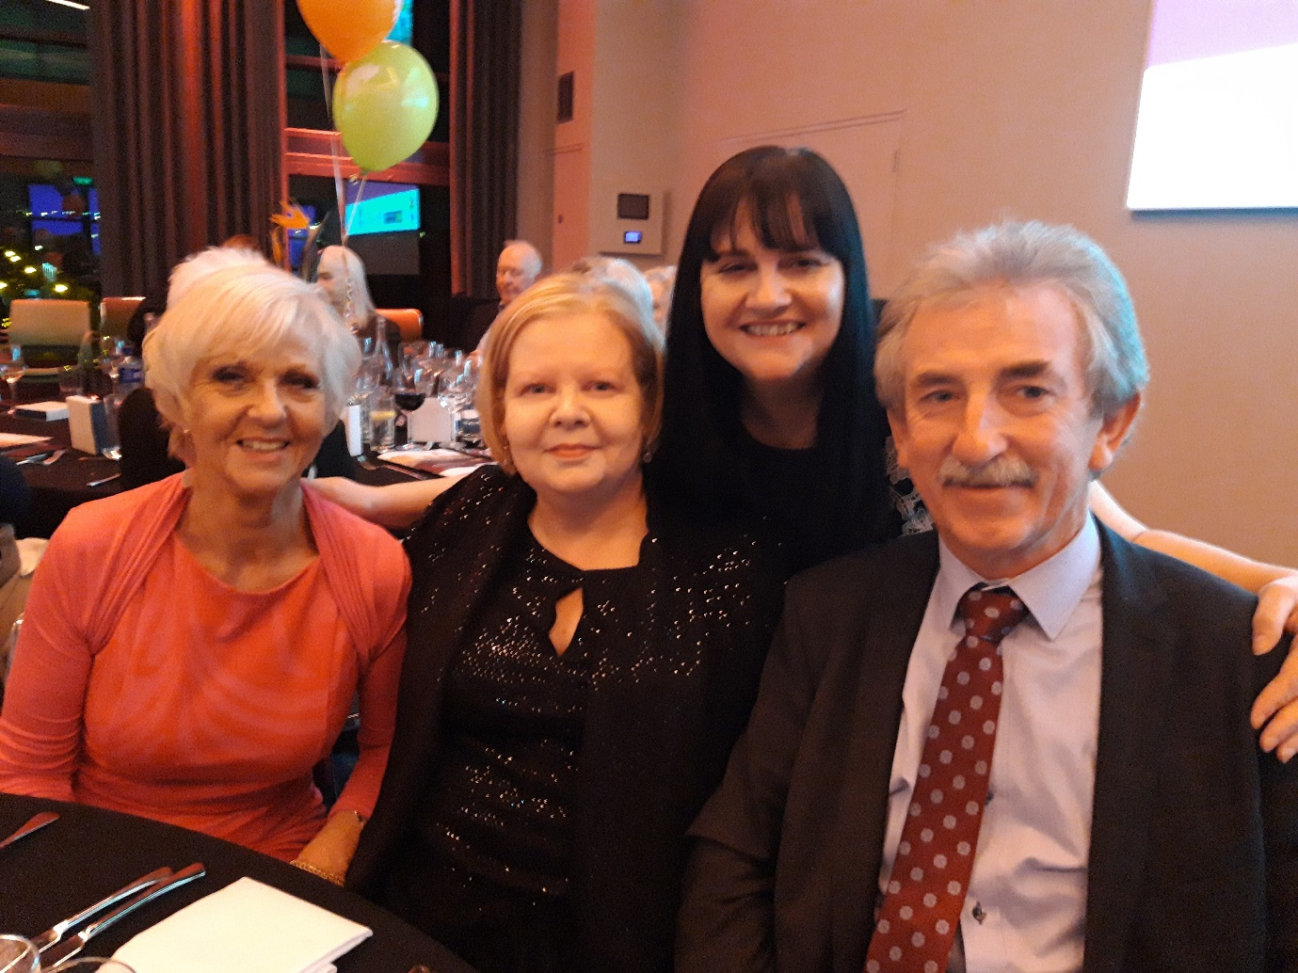

Mary Delaney KOPC member, Monica Cox, Chairperson KOPC, Alice Corbett, Regional Manager for South East Region and Norman Farragher vice-Chairperson KOPC at National Awards night.

Action- Member of LEO team has been trained up to deliver training on age friendly business
Athy will be the first town but has been put on hold due to Covid 19

All Thematic Areas
Action- Health and Wellbeing Festival Cancelled due to Covid19
Online exercise programmes and videos replaced the festivals for the time being

Action- Leixlip Walkability Audit
The walkability audit had been planned but was cancelled due to government restrictions

Action- Age Friendly Towns
There were no new age friendly towns, however the Age Friendly estate programme was implemented successfully in Castlefen, Sallins.
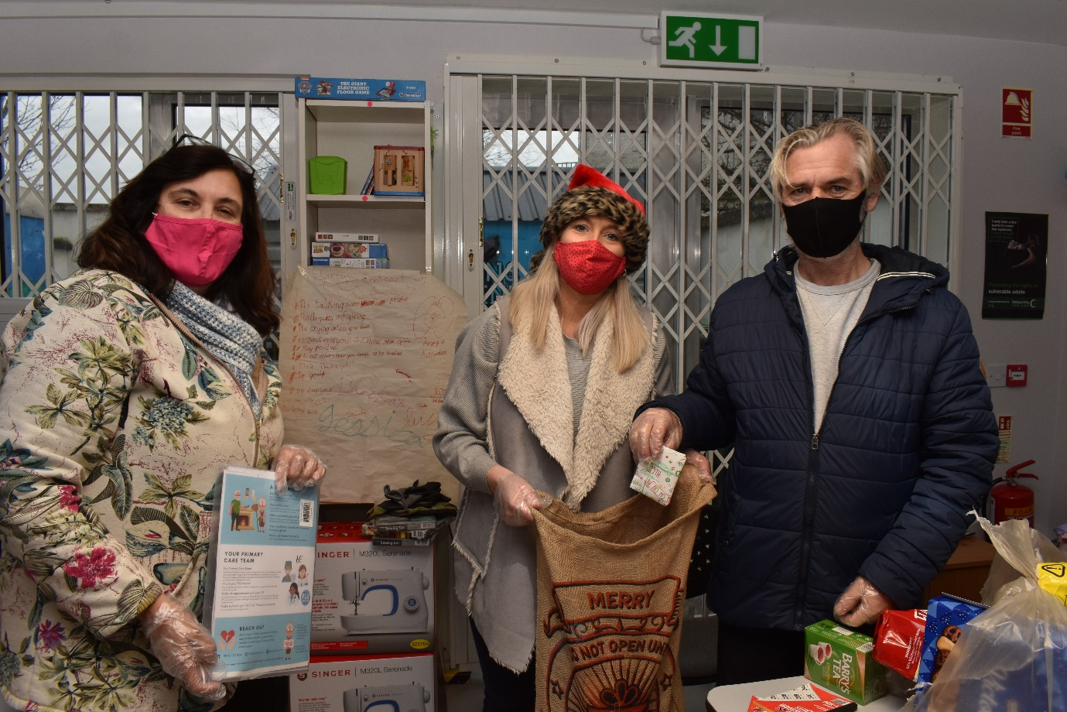

Carmel Cashin Community Worker KCC with John McLoughlin Chairperson Castlefen Residents Association
Sallins and Cheryl Reilly, Treasurer packing up their hampers in their fully adapted age friendly Community Centre in their Local Authority Age Friendly Estate

Action- To continue ongoing support for the alliance, report to the LCDC and provide employment opportunities for older people.
Support for the alliance has continued, and reports to the LCDC are regular. Employment opportunities are currently on hold due to Covid19

